Jennifer Stegina

22 September 2019

CIS 250

**Unit 5 Graded Exercise 1**

The following questions come from the “Check your understanding” examples in Chapter 15 in your textbook.

After you are finished, please submit a Microsoft Word file that contains screenshots of the SQL queries and the output, along with a comment in each query containing your name. Your document should be named **U5_GradedExercise1_Lastname.docx**.

(15-1) Question 1:

1. Here is some information about the size of two tables:

Table 1: 10 columns 100,000 rows

Table 2: 10 columns 50,000 rows

What is the maximum size of the union of these two tables? What is the maximum size of the inner join of the tables? By “maximum size” I mean the maximum number of columns and rows.

Union max size is 150,000.

Inner join max size is 5,000,000,000.

2. Write a *select* statement to form the *union* of the *twos* table and the threes table.

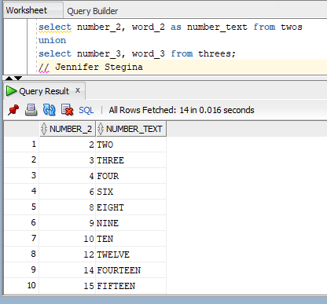

(15-2) Question 2:

Write a *select* statement to form a union of the *twos* table and the *threes* table. Use *union all*. How does this differ from using a regular *union*?

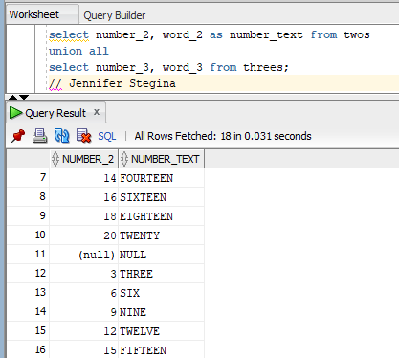

Union all keeps the duplicates and the null values. So, union all has 18 rows compared to the 14 rows of a regular union.

(15-3) Question 3:

1. What is wrong with this *select* statement?

*select number_2*

*from twos*

*union*

*select number_3,*

*word_3*

*from threes;*

That query needs to have either one column selected from both tables or it should have two columns selected from both tables. The number of selected columns from each table needs to match up.

2. Goal 1: Show that a *union* is similar to an *insert* statement in that it can add new data to the result table.

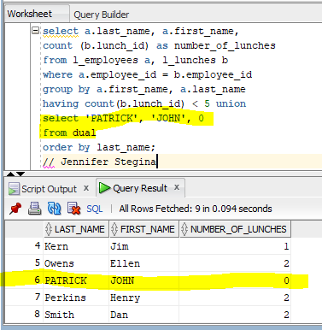

3. Goal 2: Show a *union* that uses more than two *select* statements. The following select statement shows the number of lunches that each employee will attend, but it does not account for Carol Rose or Paula Jacobs because they are not attending any lunches. Modify this statement to show that these two people will not attend any lunches.

*select a.first_name,*

*a.last_name,*

*count(b.lunch_id) as number_of_lunches*

*from l_employees a*

*inner join l_lunches b*

*on a.employee_id = b.employee_id*

*group by a.first_name,*

*a.last_name;*

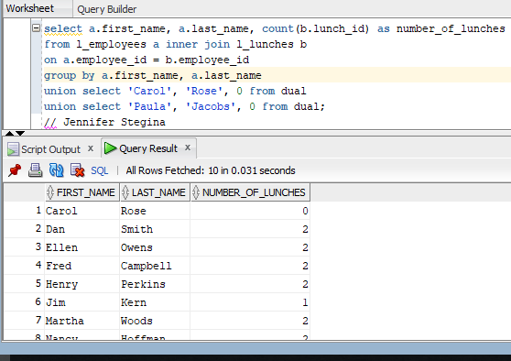

(15-4) Question 4:

Modify the following *union*. Add an *order* by clause to it to sort the rows by the last name. Try all four methods. Which ones work?

*select a.first_name,*

*a.last_name,*

*count(b.lunch_id) as number_of_lunches*

*from l_employees a*

*inner join l_lunches b*

*on a.employee_id = b.employee_id*

*group by a.first_name,*

*a.last_name*

*union all*

*select 'Carol',*

*'Rose',*

*0*

*from dual*

*union all*

*select 'Paula',*

*'Jacobs',*

*0*

*from dual;*

“Oracle doesn’t support using a table alias in an order by clause of a union (Patrick, 2009).”

Using a column number in the order by clause works, using a column name works, and using a column alias works.

(15-5) Question 5:

Goal: Show that a *union* can add new rows of data to a table. This is similar to what an *insert* statement does.

First, create a *select* statement that lists all the columns and rows of the *l_employees* table and uses a *union all* to add the following new employee. Then save the result table as a new table called *sec1505_employees*

Employee_id: 301

First_Name: Gail

Last_Name: Jones

Dept_code: Sal

Hire_date: Feb 15, 2011

Credit_limit: $25.00

Phone_number: (null)

Manager_id: 202

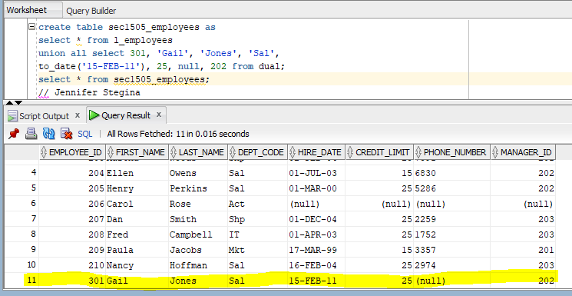

(15-6) Question 6:

Run the code from this section. Use the methods of **section 7-12** to examine the datatypes of the columns of the beginning tables and of the new view created by the *union*. Have any of the datatypes changed in the process of forming the union?

Sec1506_union_view



Sec1506_with_long_columns



Sec1506_with_short_columns



Yes, the text column in the created view is a datatype varchar with a maximum of 7 characters. The text column in the two previously existing tables are varchars with a maximum of bytes (long having 7 bytes and short having 2 bytes).

(15-7) Question 7:

Modify the following select statement. Convert the datatypes of all the columns to text. (Actually, sometimes this code will work as it is and the conversion of the datatypes is done automatically for you behind the scenes.)

*select date_1,*

*date_1,*

*date_1*

*from sec1507_first*

*union*

*select number_2,*

*word_2,*

*date_2*

*from sec1507_second;*

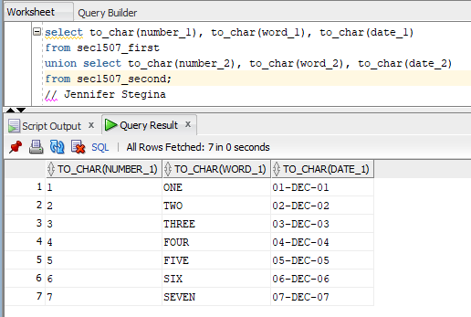

(15-8) Question 8:

Modify the following *select* statement to make it work. Add one more columns to the second *select* statement. You can use either a null or a literal value.

*select number_1,*

*word_1,*

*date_1*

*from sec1508_more_columns*

*union*

*select number_2,*

*word_2*

*from twos;*

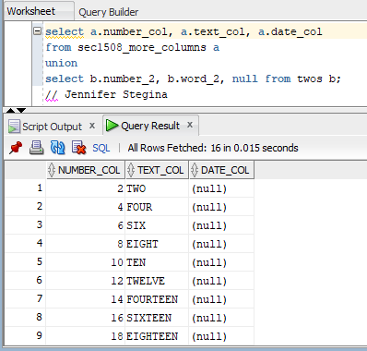

(15-10) Question 9:

The following *select* statement creates a *union* of the *twos* table with the *threes* table. Add a new column to show the table from which each row comes.

*select number_2,*

*word_2*

*from twos*

*union*

*select number_3,*

*word_3*

*from threes*;

